90% 사카로스 10% water

1:1 사카로스+water:SAP 질량비

Ecoflex 주원료+하드너 1:1 질량비

N<30이면 정규성 만족 X -> 정규성 검정 해야함 Cyton board 31.2Hz ADS1299

EEG Recorded from the Ear: Characterizing the Ear-EEG Method (2015)

<https://www.frontiersin.org/articles/10.3389/fnins.2015.00438/full>

EEG와 in ear-EEG 함께 사용

Impedance: more than two electrodes 10 k ohm, gel 사용

재질: 3D printing

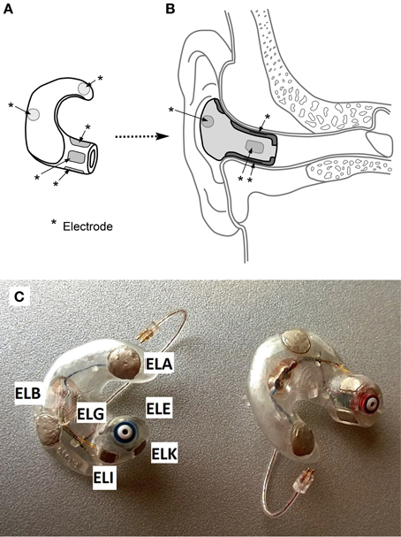

Paradigms probed auditory onset response, mismatch negativity, auditory steady-state response, alpha power attenuation

Auditory mismatch response는 모니터링 하기 힘듦

Each ear canal, concha 6개

ERB가 양쪽 귀에서 ground, reference는 scalp Cz electrode

High viscosity conductive gel,

13 individuals 23-43, median 30, five females

ASSR,

Paradigms

ASSR: white noise (amplitude modulation 40Hz) binaurally for 4min. 20Hz trigger. Signal sampling 256Hz

Mismatch Negativity (MMN) paradigm: standard beep consisting of a mixture of sinusoidal tones of 500, 1000 and 1500 Hz, lasting 75ms.

Oddballs: low/high pitch, low/high volume, left/right delay, reduced duration or having a gap1845 stimuli. 15min and 20s (3 sub-sessions) each sub-session 15 standard stimuli 600 alternating standard and oddball stimuli. 4session totaling 7380 stimuli.

Alpha-attenuation paradigm – rest with closed eyes, doing simple arithmetic in the head with open eyes. 50에서 100까지의 수가 10초마다 바뀌고, 7을 계속 빼는 작업. 1분 간격의 소리가 들리고, 눈을 감고 쉬는 작업과 눈을 뜨고 계산하는 작업이 반복됨.

Data Preprocessing

32 scalp channels, 11 ear channel.

기록하는 동안은 Cz를 Ref로 사용했지만, 적절한 ear-EEG 데이터셋은 ExA 전극을 사용함으로써 얻어짐. “cross-referenced”는 반대편 귀의 모든 non-discarded 채널을 평균냄으로써 얻어짐.

Electrodes를 rejected하는 2 criteria (ExA-Reference)

1. ASSR에서 clear 40Hz peak을 가지지 않는 경우. The precise criterion for “clear” was a 9 dB amplitude-difference relative to surrounding noise floor, a value chosen because it most cleanly partitions the distribution of measured amplitude-peak-heights in distinct sets of high and low values. This accounts for a channel rejection rate of 7.7% in the ExA-referenced dataset.
2. Cz-referenced mismatch response가 TP9 TP10(귀와 가까운 위치에 있는 것들)과 비슷한 형태를 갖지 않는 것들. 귀 전체를 rejection하지는 않음 -> 비슷한 ERP를 가지는 피험자들에게 편향된 결과가 아님. 9.3%.

MMN Paradigm: FIR 3-30Hz pass band filter. [-100ms, 600ms]. Baseline [-100ms, 0ms]. R^2>0.2이면 trend-corrected 됨.

Alpha-attenuation Paradigm: The pass band 0.5-45Hz. Epochs 4s. same with MMN.

Total channel rejection 17%.

3 Results

3.1 Cz-referenced ERP

MMN 150ms peak

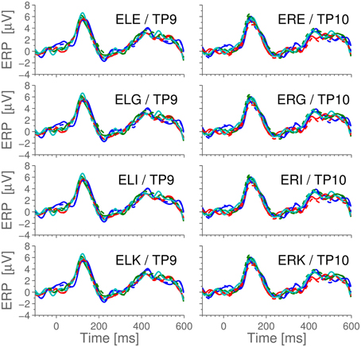

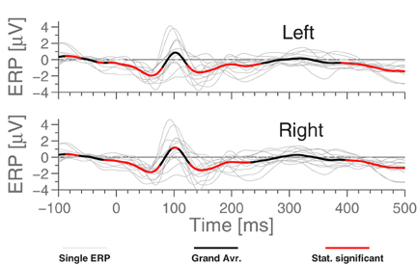

3.2 ASSR

Reference – ExA로 사용. Signal-to-noise rations (SNR) 측정. SNR; difference between the logarithm of the power at 40 Hz (the signal) and the logarithm of the average power in 5 Hz intervals around 40 Hz (the noise floor)

계속 t-test 사용하는데, 모집단은 3개 이상이니 ANOVA를 사용해야하지 않나? T-test로 비교하는 모집단 두 개가 무엇인지 모르겠음.

비고: 이 방식들은 scalp electrode와 비교하여 in-ear EEG가 타당한지를 판별하는데, deep brain에서 EEG 신호를 받는 경우와는 그 결이 좀 다를 수 있음. 표면 cortex의 신호만을 재는 scalp EEG로 Deep brain의 EEG 신호를 판별할 순 없기 때문.

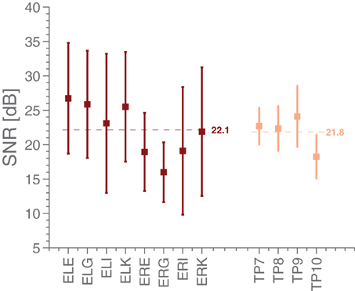

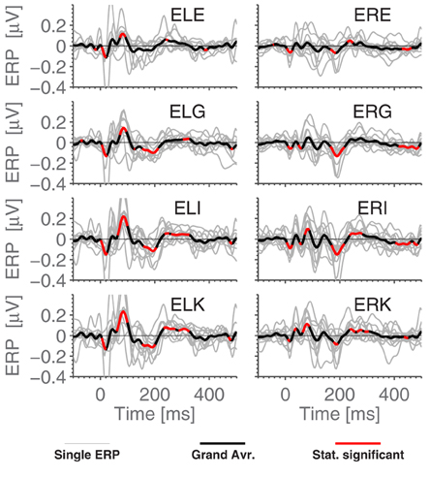

3.3 Ear Referenced ERPs

Fig5-MMN. Correlation coefficient between sessions (1800 stimuli) on the same person averages to 0.45, while using the set of 7200 stimuli, we find 0.80 between EEG channels in the same ear and 0.75 between ear averages.

부호 반대

Timings of middle latency deflections(8~10 msec부터 50~80 msec) Fig6 timings of the early to medium latency AEPs (Auditory Evoked Potentials) We find that the polarities of the potentials, for the considered electrodes, are opposite to those reported in Picton et al.

MMN paradigm에선 significant한 MMN response를 밝혀내지 못함

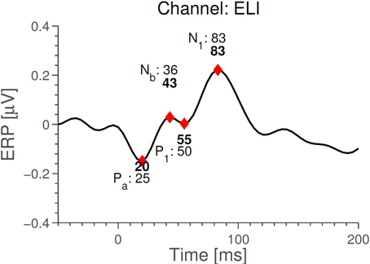

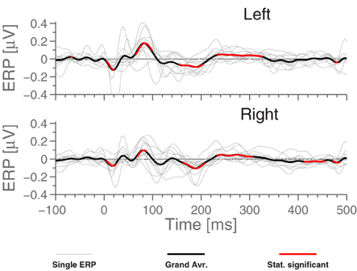

3.4 Same Ear Referenced Alpha Power

둘 다 구분 잘됨. Scalp가 좀 더 contrast가 잘 드러나지만, ear-EEG도 잘 드러남.

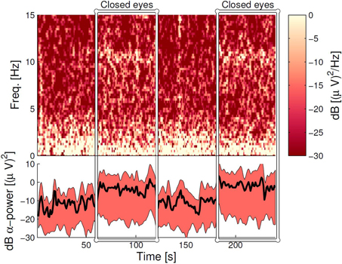

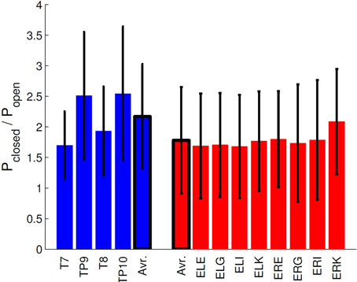

4 Discussion

ExA-referenced ERPs의 경우 onset response는 잘 잡아내지만 MMN은 잘 잡아내지 못하는 모습을 보임->이는 MMN의 frontal sources가 primary auditory cortex보다 비교적 귀에서 더 멀고, electrode와 reference가 가까울 때 source로부터의 거리와 진폭이 거리의 세제곱에 반비례하기 때문으로 보임-> 이는 SNR이 귀에서 좋지 않게 측정되는 이유.

Local ExA-electrodes가 reference로써 사용될 경우, 왼쪽 귀와 오른쪽 귀에서 ERPs에 차이가 나는데, 이를 짧은 전극 거리가 증폭시키는 좌반구와 우반구의 해부학적 차이로 보고 있음.

Alpha-activity의 resting/working states의 비교, 그리고 ASSR 측정에서 ear-EEG가 낮지만 frequency-domain 분석에 적합함을 발견함.

두 가지 중요 코멘트

-positive result는 ear-EEG와 scalp EEG 사이의 어떤 연관성 때문에 발생한 것이 아님. 둘이 가깝지만 다른 reference를 사용했고, 매우 다른 ground를 사용했음. 또한 ExA를 measurement 후에 reference로 사용하기 전, ExA를 시작할 때부터 reference로 사용하는 것에 대한 pilot study를 마침

-젤이 귀 안에서 밀착하는 경우에 대한 문제. 이를 해결하기 위해 ear piece design을 바꾸거나 dry electrodes를 사용하는 방안에 대해 진행중. 또한 reference를 항상 귀 밖에 둠으로써 문제에 대한 민감함을 낮춤. Fig 4-8은 신호가 neural processing의 산물로 인해 결정되며, gel-based artifacts는 주요 요인이 아님을 보여줌.

5 Conclusion

Oddball MMN에서 귀가 primary auditory cortex와 가깝기에 ERP를 측정할 순 있지만, MMN의 source가 귀와 거리가 좀 있어 측정에 어려움.

ASSR과 alpha-attenuation paradigm을 통해 ear-EEG가 frequency analysis에 적합함을 보임.

Furthermore, work has been done to map the vulnerability of the platform toward physiological artifacts; here it has been found that the effect of jaw, head and eye movements were comparable for ear-EEG and scalp EEG (Kappel et al., 2014).

Alpha-activity, ASSR>MMN

ERB-ground

정리하자면, paradigm은 총 3개.

1. Auditory Steady-State Response (ASSR)
2. Mismatch Negativity (MMN) paradigm
3. α-attenuation paradigm

3.1 Cz-referenced ERP – MMN ERP

3.2 ASSR – ASSR’s SNR

3.3 Ear Referenced ERPs – MMN ERP, middle latency AEPs

3.4 Same Ear Referenced Alpha Power - α-attenuation spectro gram, average ratios in the two states

Reference

ASSR Alpha, MMN

[A Study of Evoked Potentials From Ear-EEG]

Impedance: below 5k ohm, conductive gel 사용

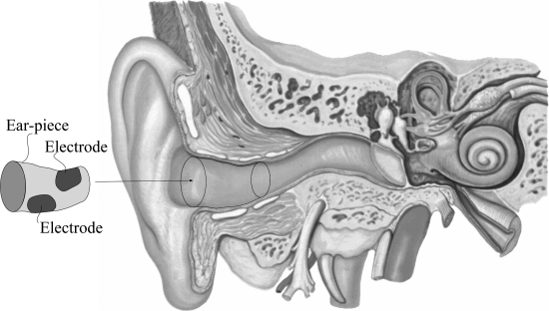

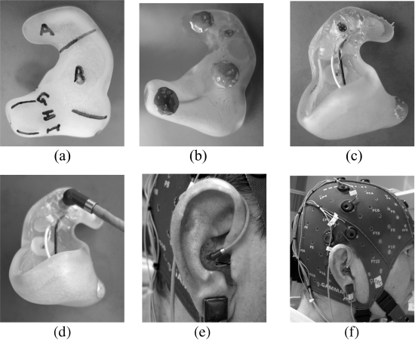

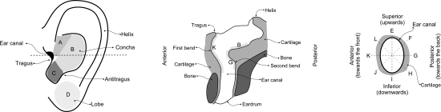

Ear-EEG에서는 ExH (ear canal)을 reference로 사용, scalp EEG에서는 right ear lobe를 reference로 사용 -> 두 EEG에서 사용한 reference의 거리가 꽤 있음.

One-Step, Three-Factor Pass through Authentication with Custom-Fit, In-Ear EEG

[CNT/PDMS-based canal-typed ear electrodes for inconspicuous EEG recording] 2014

Dry electrode, 일체형 electrode

Steady-state visual evoked potential (SSVEP)]

Bio- and skin-compatibility of CNT/PDMS were tested.

Metal을 사용하는 경우 direct contact of metal to skin may cause skin trouble when used over the long term

Evaluated by measuring the contact impedance and Young’s modulus.

Alpha rhythm, N100 AEP, SSVEP, ASSR 편의성과 사용 용이성 평가하는 설문지.

2.3.1 Alpha wave detection 8-14

Comfortable chair에서 20초간 눈 감고 뜨고 반복. Spectrogram analysis에선 10초간 눈 뜨고 감고 반복.

2.3.2. N100 Auditory evoked potential (N100 AEP)

Dominant N100 AEP dominant negative peak of an EEG after one

Randomly 1 to 1.5s in order to prevent adaptation to stimuli

2.3.3 SSVEP

LED

2.3.4 ASSR

Binaural Beats 쓰는듯? – selective ASSR tests

2.4 Biocompatibility

두 가지 테스트

* 1. Cytoxicity of the electrode materials by culturing skin firbroblast cells on the CNT/PDMS. Dulbecco's modified Eagle medium (Gibco) seven days. Viability - Live/dead assay kit. Stain – inverted fluorescence microscope.
* 2. Skin compatibility – itching, swelling, or redness. CNT/PDMS sheet was attached to the upper arm with air-permeable tape. 7 days.

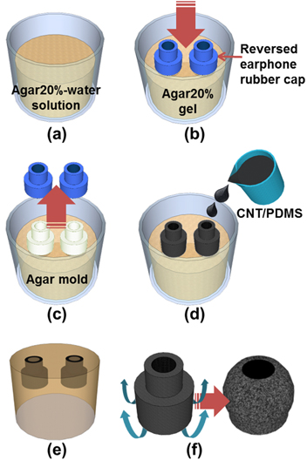  
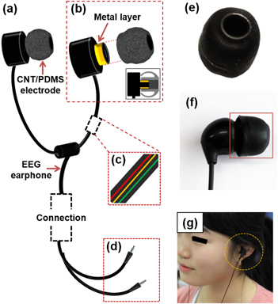

3. Results

3.1 Electrical and mechanical performance test

Impedance of the CNT/PDMS and Ag/AgCl standard electrodes 1Hz-1000Hz

Frequency 증가하며 impedance 감소 CNT/PDMS 1M Ω <5Hz 300k Ω<4Hz

Stress-strain curves Young’s modulus almost constant at 1MPa

3.2 EEG Measurement

60Hz power noise

PSD FFT는 정현파(사인파, 코사인파) 분석에는 용이하지만, 랜덤파 분석은 샘플링 시간이 길수록 안 좋아지기에 PSD(Power Spectral Density)를 사용함

CNT/PDMS 신호가 wet electrode와 유사함, eye blinking artifact로 그 효과를 확인함

3.2.1 Alpha rhythm detection

Alpha band (8-14)에서 dominant peaks 10-12Hz

Eye closed: 10-12Hz에서 red line

Spectrogram에서도 10초 이후로 확인 가능

Mean PSD of alpha로도 확인: closed에서 훨씬 증가

SNR 수치는 비슷

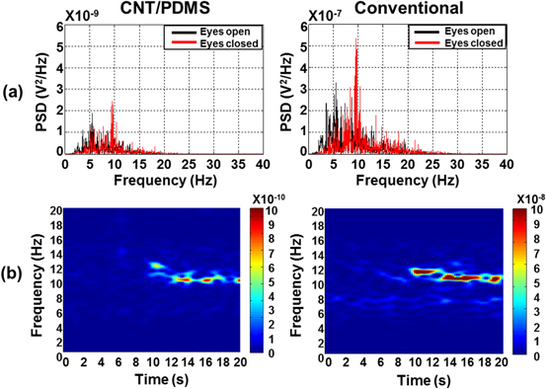

3.2.2 N100 Auditory evoked potential

AEP- verify the validity of the CNT/PDMS CEE (100 auditory stimuli, beeps)

N100 peak (80-120ms) -verify by t-tests to determine p-value

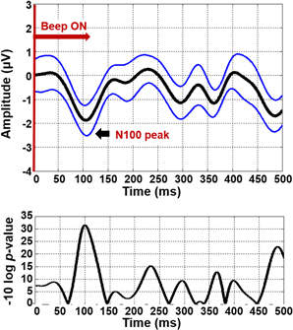

3.2.3. SSVEP

SSVEP normally appears as a dominant peak at a specific frequency accompanied by sub-harmonics. (14, 28, 42 Hz)

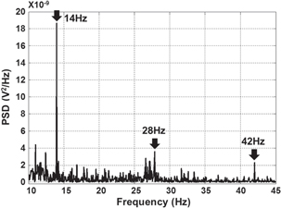

3.2.4. Auditory steady-state response (ASSR)

40Hz ASSR -40 Hz peak, on-scalp-type peak이 더 크긴 함. 하지만 CNT/PDMS가 high SNR을 가짐

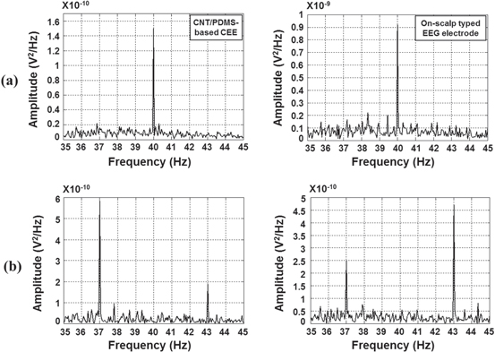

3.3 Bio- and skin-compatibility test

Live/dead assay kit >93% skin fibroblast cells 7 days 섬유아세포. Control dish에선 99%

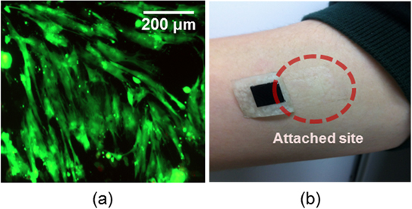

3.4 Comfort survey

CNT/PDMS가 conventional electrode보다 편안하다고 보고.

4.Discussion

High impedance electrodes가 artifact에서 sensitive할 수 있지만, BCI에서 사용되는 EEG signal은 high frequency고 artifacts는 0-5Hz의 low frequency라 주장. EMI(electromagnetic interference)는 electrical shielded wire를 사용함으로써 무시된다고 봄. 하지만 SNR은 기존 electrodes와 유사.

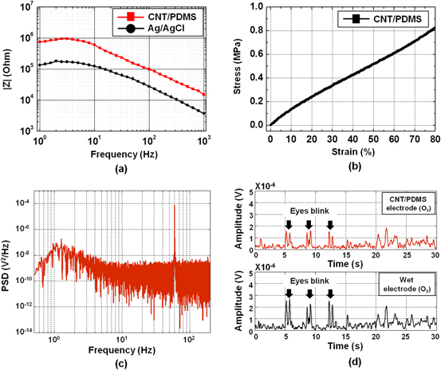

귀에 부착 시 Alpha rhythm signals가 filtering 없이는 time domain에서 유의미한 결과 없었음. -> Oz와 비교하여 진폭이 아주 낮은 이유-> 귀에선 alpha activity가 너무 낮기 때문. 더욱이, N100 AEP와 SSVEP는 성공적으로 측정됨.

Cross-talk(혼선) 이슈. However, when the sound signal was amplitude-modulated, its frequency band became much higher (beside the carrier frequency) compared to the EEG band, so cross-talk could be ignored, although cross-talk was observed in the EEG signal.

[A Study of Evoked Potentials from Ear-EEG]

Electrode 종류 Ag

2013년 논문으로 transient response도 봄

ExH reference, ExA grounds. ExB,ExE records.

On-scalp EEG 8 electrodes (10-20 electrode system, T7, Tp7, Tp9, T8, Tp8, Tp10, Oz, and Pz) relative to the right ear lobe (reference) and the Cz electrode as ground (common mode feedback)

Conductive gel 사용, electrode impedances <5kΩ

S3. Evoked Potentials: Methods and Stimuli

The amplitudes of EP are in general much lower than the amplitude of the spontaneous EEG, making it necessary to average over multiple trials in order to reveal the ERPs. However, since ERP waveforms typically last for several hundreds of milliseconds, the data segments used for the averaging often contain ERPs from previous stimuli. As a consequence, the averaged waveform will deviate from the true underlying ERP waveform, and this distortion may be significant even for rather long interstimulus intervals. a way to reduce this distortion is to apply a random interstimulus interval (jittered timing) which effectively filters out the high frequency components from the underlying true ERP waveform. As the range of the random interstimulus interval is increased, the lower frequency aliasing components from the averaged waveform are reduced, see e.g., [9] for more detail. : Interstimulus interval을 랜덤으로 증가시켜야 하는 이유: 시간이 어느 정도 지나도 남아있는 ERP 신호가 averaging으로 인해 발생할 수 있는 distortion을 방지하기 위함 lower frequency 얼라이어싱 방지

반복적으로 높은 진동수의 신호를 줄 시 과도응답 (transient response)->정상상태 응답 (steady-state response)으로 변형

1. ASSR

Amplitude modulated white Gaussian noise, both 40 and 80 Hz amplitude modulation.

8 on-scalp 4 ear-EEG electrodes, 8 different subjects

1. SSVEP

Light intensity에 크게 의존하긴 하지만 75Hz까지 감지 가능. Most sensitive in the region around 10Hz. 이 신호들은 일반적으로 occipital and parietal lobe에서 측정됨.

10, 15, 20 Hz 50% duty cycle로 사용됨.

1. Transient Auditory Evoked Potential

Auditory cortex에서 P1-N1-P2 complex 확인. 1kHz sinusoid of duration 200ms, attack and release time 10ms. Interstimulus interval 1.7~2.3 s.

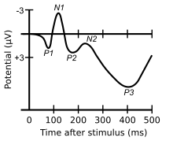

1. Transient Visual Evoked Potential

Visual evoked potential (VEP) primary visual cortex. SSVEP와 같은 빛. 5ms duration, uniformly distributed between 300 and 500ms.

array of 3 × 3 white 5 mm LEDs at a distance of approximately 25 cm from the subject

S4. Results

1. ASSR

40Hz modulation (frequency resolution 1Hz) ELB(ear electrode)

First and second harmonic component

On-scalp SNR 20dB ELB 35dB -> 전체 amplitude가 낮더라도 SNR이 높으면 양호한 신호를 뽑아낼 수 있음

Amplitude가 낮은 이유: 1. electrodes 간 거리가 짧기 때문 2. Brain과 ear canal 간의 bone structure가 brain과 surface of the scalp보다 두껍기 때문

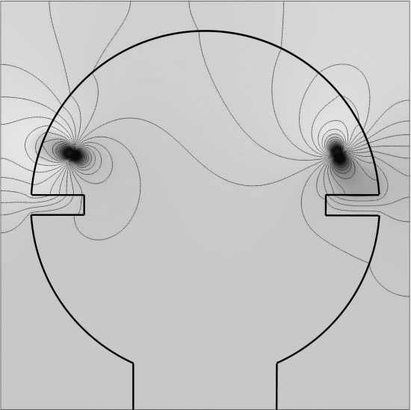

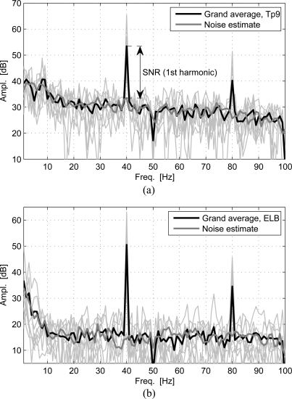

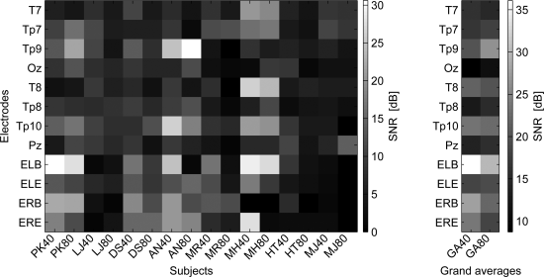

SNR이 전체적으로 ear 쪽이 높음

t-test로 significance 측정

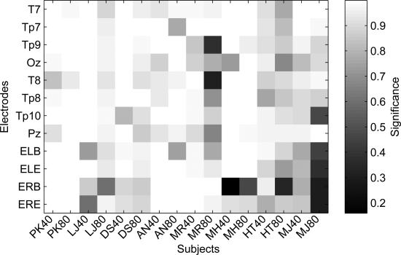

1. SSVEP

여러 위치에서 관찰 가능 TP9, ELB 포함. 10Hz. harmonics에서 peak 관찰됨.

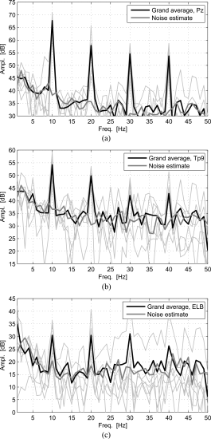

Pz 30dB, Tp9 17dB, ELB 10dB

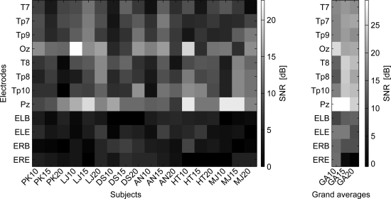

1. Transient Auditory Evoked Potential

Transient AEP를 ear-EEG에서도 캐치해낼 수 있는가? EEG 파형이 비슷하므로 그렇다.

여기서 SNR은 (i.e. the ratio between the amplitude of the waveform and the standard deviation)으로 앞과 좀 다르다. Ear-EEG의 SNR이 좀 더 작았는데, 이는 ear-EEG의 내재적인 문제가 아닌 amplifier noise 때문으로 생각됨

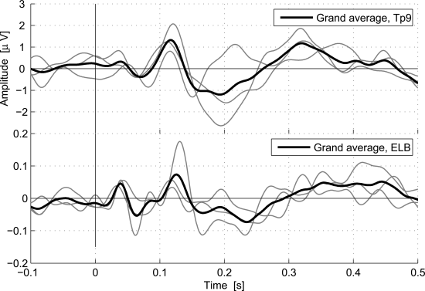

1. Transient Visual Evoked Potential

Oz,Tp9,ELB

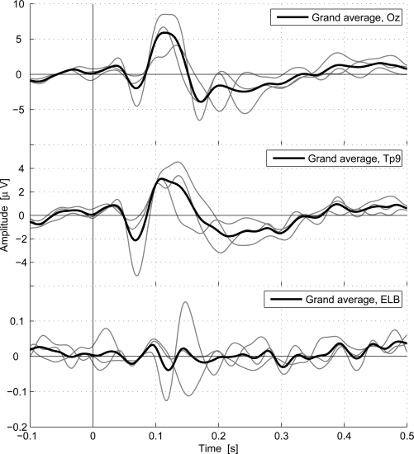

Ear-EEG가 scalp보다 20dB 정도 낮음. 하지만 중요한 건 파형이 비슷한 것. 논문에서는 파형이 비슷하다고 말했지만 개인적으로는 그렇게 보이지 않는다고 생각함. Transient VEP에서 SNR에 대한 이야기는 없음.

S5. Conclusion

Ear-EEG amplitude가 scalp EEG와 비교하여 20dB 정도 낮음. 하지만 ASSR의 경우 signal quality는 유사. Transient response는 temporal에서 waveforms가 비슷함. SNR은 낮지만 이는 ear-EEG의 내재적인 문제가 아닌 amplifier noise 때문인 것으로 보임.

[Emotion Recognition Based on Low-Cost In-Ear EEG] 2017

REF: right earlobe GND: chin

2A. Data Collection

Music과 video materials를 DEAP data experiment를 통해 선정함. Athletes 와 rock music을 통해 excited emotion을 유도하고, scenery video와 What a wonderful word를 통해 relaxed emotion을 유도하고, car accident video와 terrible noisy music Lost rivers를 통해 negative emotion을 유도함.

In-ear EEG device는 Neurosky Mindset EEG headeset을 refitting하여 사용. 512Hz sampling rate.3-100Hz bandpass filter. 후보군에는 Emotive와 Muse 등의 제품도 있었음. Neurosky가 가장 저렴하고, real-time BMI application을 위한 OpenVibe를 support하기에 채택.

Modification: the modifications made to the original dwNeurosky Mindset included releasing the electrode from the plastic forehead arm, removing the electrode, and replacing it by soldering a new 10mm disc-shaped Ag/AgCL electrode onto the original wire. An elastic earplug was used to support the electrode and make it tight fit to the upper edge of the ear canal.

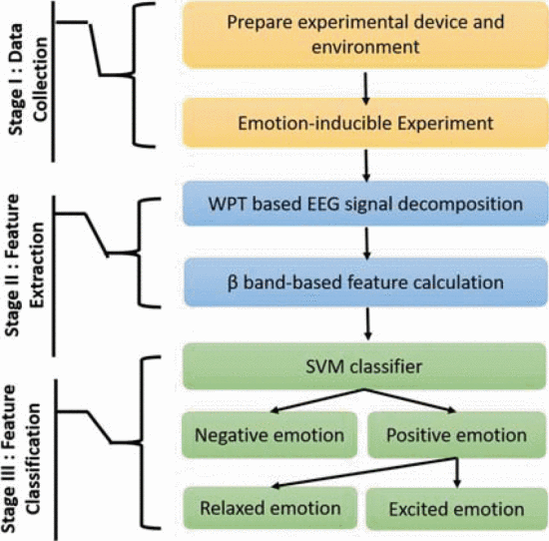

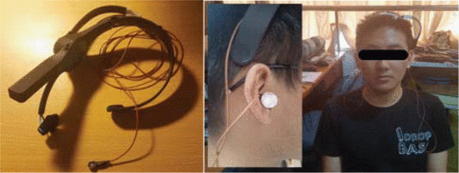

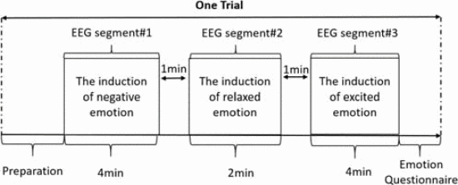

각각의 비디오를 몇 분 간 보여줬는지에 대한 이야기 없음. EEG 착용 후 3 종류의 감정 유발 비디오 보고, post-experiment questionnaire.

Negative emotion (low valence, LV), relaxed (high valence and low arousal, HVLA), excited (high valence and high arousal, HVHA), according to J.Russel’s model.

Emotion model: J.Russel’s circumplex model

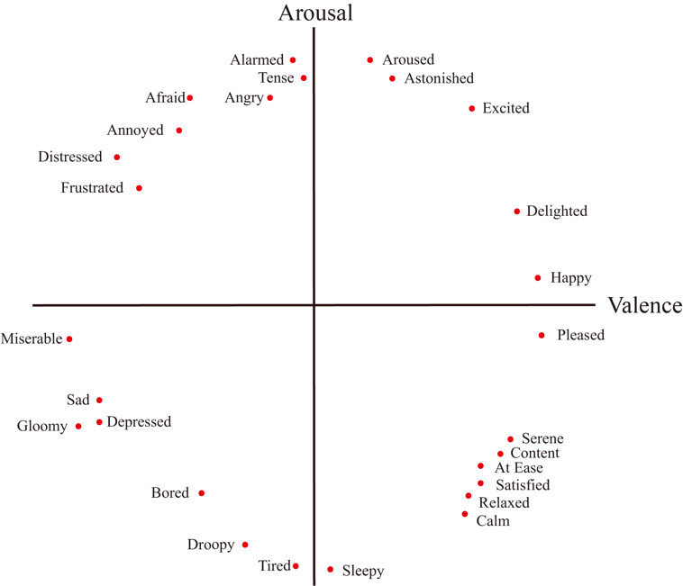

만약 self-reported emotion이 실험자들의 예측과 다르거나 ‘not strong during the experiment’라면 다시 실험. 2차 실험에서도 여전히 다르다면 유효 샘플로 처리되지 않음.

B. Feature Extraction

EEG signal이 non-stationary (비정상)하다는 것을 가정함.

Regular wavelet decomposition: Discrete wavelet transform (DWT) decomposes the given signal into a set of approximate and detailed coefficients for the nth level

Wn,m   
[mfS/2^(n+1)Hz,(m+1)fS/2^(n+1)Hz]

Fs: sampling rate

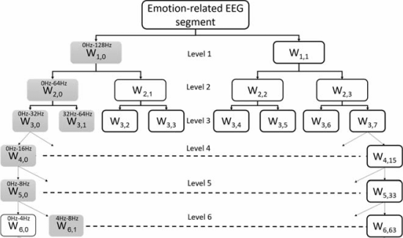

WPT decomposes not only the approximate coefficients, but also the detailed coefficients

DWT에서 유실된 high frequency 정보는 WPT를 이용해 회수 가능

WPT decompose는 emotion-related EEG segments를 coiflets mother wavelets with order 5로 8 level로 분해함

W8,14 W8,29는 β band에 해당함.

Relative power spectrum energy of β band, variance of β band, sample entropy of β band가 계산됨. 그리고 Normalized된 variance, power, entropy가 SVM classifier에 사용됨. Variance β는 Varβ_relaxed/Varβ_negative and Varβ_excited/Varβ_negative.로 계산됨.

C. Feature Classification

Primary advantage of SVM: Minimize both structural and empirical (경험적) risk, thereby leading to better generalizations for new data classifications, even with limited training datasets.

Binary classification이 negative/positive (excited & relaxed) emotion을 구분하기 위해 사용됨.

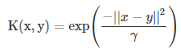 Evaluation 1 (RBF kernel)

C, γ는 grid-search를 통해 best cross-validation accuracy를 보여주는 값 C=100,000 γ=1

LibSVM을 통해 SVM 구현.

Grid search: 일정 간격으로 parameter를 조정

Radial Basic Function (RBF) 1. 숨겨진 층이 하나뿐이라는 것이 특징이며, 2. 선형 출력 층을 가지고 있다. 3. 선형 출력을 가지고 있기 때문에 가중치 계산에 용이하다 4. 가중치를 업데이트 규칙은 쉽게 연산 할 수 있다. 5. 이 특징들로 인해 지능형 제어 어플리케이션에 장점이 있다. 6. 학습이 MLP보다 빠르다는 것이 장점이다. 7. 유클리드 거리 측정 데이터를 기반으로 동작한다

Linear & polynomial kernel 비교 후 RBF kernel이 채택됨

Leave-one-subject-out cross-validation이 classification accuracy 측정을 위해 사용됨

3.Results and Conclusion

34/36(12 sub * 3 emotion-related segments) EEG segments

여기서 Varβ, SamEnβ, Pβ가 추출됨 Box-whiskers plots normalized Varβ linear increasing trend with the increase of valence, SamEnβd와 Pβ에선 아님. -> SVM과 같은 non-classifier를 사용한 이유

Extracted features가 RBF-based SVM classifier에 사용됨.

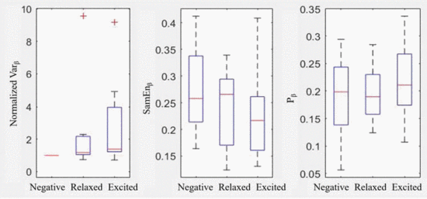

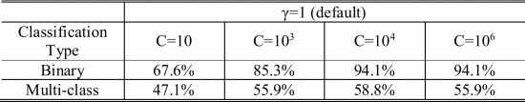

Negative-positive Binary classification 67.6-97.1%

Negative relaxed-excited Multi-class classification 47.1-58.8% C=100,000 γ=1일 때 제일 높음.

Excited/Relaxed 59% - decrease in accuracy for arousal recognition

Decrease의 두 가지 주된 이유: 1. Relatively low level of stimulated excited emotion in data collection experiment 2. Own mechanism of in-ear EEG

결론: Single-channel in-ear EEG가 emotion recognition에 사용될 수 있지만, arousal recognition에는 poor

개인적 생각: 혹시 time domain으로 감정 예측할 수 있을까? Valence, Arousal 시간마다 나올 수 있도록.

[A Wearable In-Ear EEG Device for Emotion Monitoring] 2019

Valence 71.07%, Arousal 72.89%, All four emotions 53.72%

T7 T8에서의 결과와 유사

Different interpretations for the many kinds of emotions-emotion recognition

Emotion simplified models는 emotion을 2 categories로 분류:

1. Defining basic emotions & Using a dimensional model

6 basic emotion: Happy/Surprised/Fear/Sadness/Anger/Disgust – Facial expression recognition에 사용

1. Common dimensional model is characterized by two main dimensions (i.e. valence and arousal)

Valence (- to +) Arousal (calm to excited) 이런 식으로 구분하면 emotion name으로 구분하는 것보다 덜 혼동됨

Emotion recognition에서 주로 사용되던 요소 – facial expressions and speech

하지만 지속적인 모니터링에서 ambient (주변의) light나 noise로 인해 이들은 적합하지 않음 +)privacy

Other physiological signals: Galvanic skin response (GSR), Electrocardiogram (ECG), Skin temperature (ST), Electroencephalogram (EEG)

EEG는 높은 정확률을 보여주지만, size나 setup difficulty로 인해 실제로 사용하긴 어려움

In-ear는 visual field 방해 X, positionally 안정적 (fixed inside the ear canals) 이어폰과 유사. Sweat의 영향 X, User-friendly setup and maintenance

Drawbacks (단점) fewer electrodes, covers smaller area. Low accuracy.

International 10-20 system의 T7(left ear), T8(right ear)과 비교

목차

S2 Related works S3 Material selections and system design S4 Detailed experimental protocols, Experimental results and analysis S5 Significant findings from the results S6 Conclusions

S2 Related Work

* 1. Scalp-Based EEG Emotion Classification

Majority: signal processing to improve accuracy

Koelstra et al.에서는 EEG signal의 PSD를 primary feature로 사용함. SVM classifier가 two levels of valence states and two levels of arousal states를 구분하기 위해 사용됨.

Arousal average and maximum 55.7%, 67.0% Arousal 58.8%, 76.0% valence

Huang et al., Asymmetry spatial pattern (ASP) – EEG-based emotion recognition algorithm

k-nearest neighbor (K-NN), naïve Bayes (NB), and support vector machine (SVM)

Average accuracy rates for valence and arousal 66.05%, 82.46% (PSD of EEG & SVM 사용)

Other studies에서 사용된 방법 naïve Bayes, K-NN, LDA(Linear Discriminant Analysis, based on Bayes), and ANN

* 1. In-Ear EEG Development

Looney et al. 2012가 기원. System design, verifications of signal quality

Goverdovsky et al. Viscoelastic substrate memory foam earplug, conductive cloth electrodes

Kullkami. soft and foldable electrode

Kappel et al. in-ear EEG with a soft earpiece

* 1. In-Ear EEG for Control

Eye blinks or other facial expressions

Matthies et al. In-ear headset based on a hacked NeuroSky EEG sensor – Eye winkling & ear wiggling

Multi electrodes to detect 25 facial expressions and head gestures with four different sensing technologies. 5 gestures 90% accuracy 14 gestures 50% accuracy

* 1. In-Ear EEG for Medical and Healthcare Applications

Nguyen et al. dual channel EEG – stable sleep stage classification 95% accuracy

S3 Materials and Methods

1. What type of in-ear EEG should be studied?
2. What kind of EEG signal quality would we be getting?

MMN to compare auditory ERP with T7 and T8

1. How good it is specifically for emotion classification?

DEAP (Dataset for Emotion Analysis using Physiological Signals)

3.1 In-Ear EEG Development

3.1.1 Earpieces Selection

2 Types of in-ear EEG devices

1. Personally customized earpiece

Earmolds created from wax impressions, 3D scanning, CAD editing, 3D-printing, wiring process

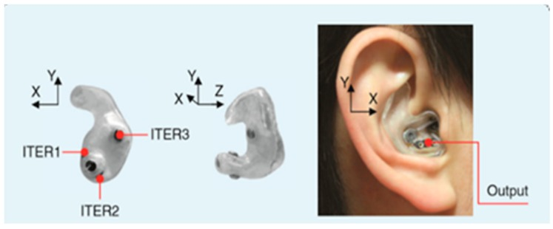

1. Generic or non-customized (low cost)

Cylinder-shaped material, cylinder of silicone, flexibility disadvantage, not guaranteed to fit into all ear canals. Improved prototype – cylinder-shaped memory foam

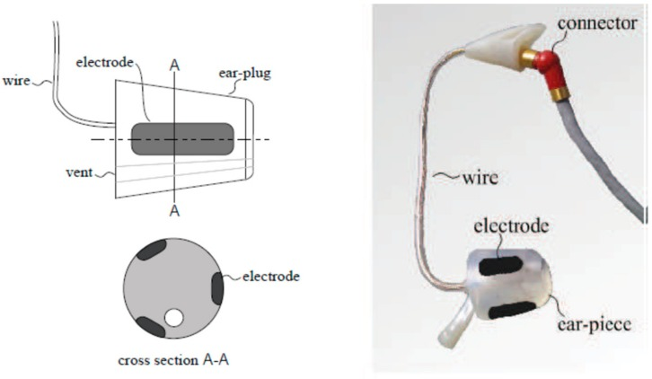

Memory foam ear-plugs – does not fit into small ear canals, gradually slip out of the ear canal – Main body of the in-ear EEG device was changed to earphone rubbers (high flexibility)

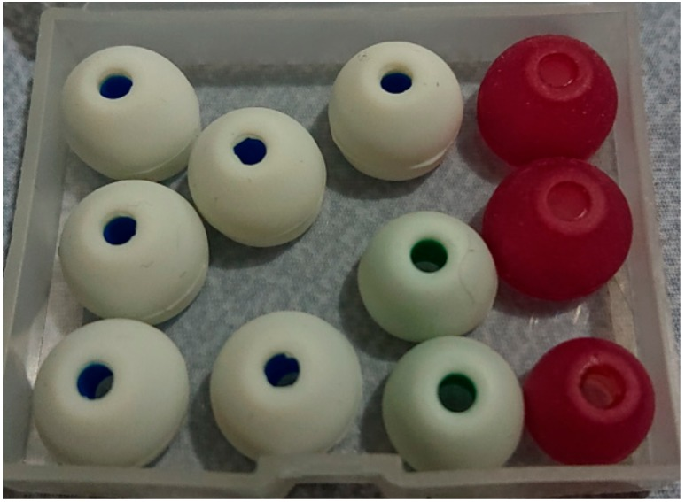

3.1.2. Electrode Selection

3 materials for electrodes (Half-sphere shaped silver, aluminum foil, and silver-adhesive fabric)

Half-sphere shaped silver – widely used, the electrodes should be as similarly flexible as possible to the earpieces to achieve robust contact (귀와 비슷한 flexibility 가져야함), but silver is solid and not as flexible as the earphone rubbers.

Aluminum foil – low impedance, good flexibility, but it could not be easily attached to electrical wires. Aluminum foil is not adhesive to soldering (납땜)

Silver-adhesive fabric – used with memory foam. Glued and sewed to the wires without soldering

->Fabric glued to the ear rubbers, shield wires, sewed to the fabrics. Number of electrodes – one channel per ear (귀 내부에서 EEG signal이 매우 비슷하다고 판단) shield wire가 normal wire보다 훨씬 크지만 noise를 크게 줄임. 개당 10$ 정도. Impedance 0.05-5.5 ohms. (openBCI wire와 비슷)

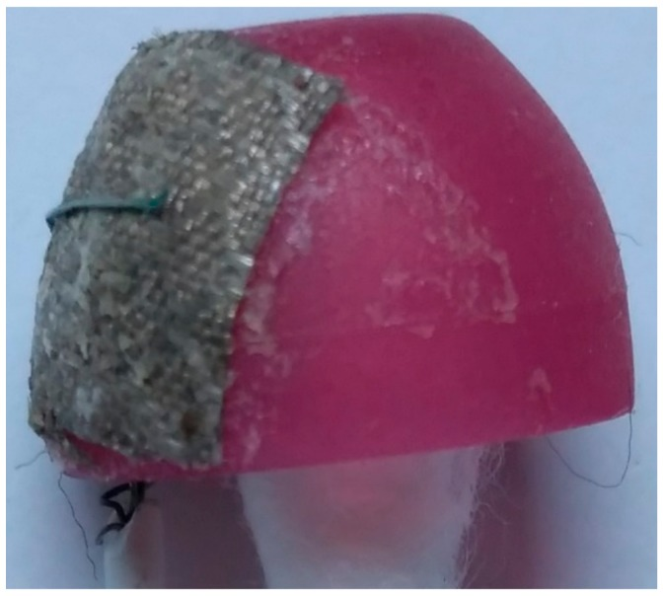

3.2. In-Ear EEG Signal Verification

MMN – EEG verification에 자주 이용됨. Auditory ERP is a subject’s EEG signal response to an unexpected change of sensory stimulation.

Tone change: frequency (lower or higher), duration (unusually longer beep duration), intensity (unusually louder or lighter), or phase -> Negative peak (90-250ms, ERP latency may be varied according to personal musical experience)

MMN – Standard tone - combination of pure tonal frequencies: 500, 1000, and 1500 Hz lasting for 75ms.

Mismatch tone – Frequency mismatch 10% lower or higher pitch randomly applied to each frequency

* Duration mismatch tone which lasted for 100ms, 25ms longer than the standard tone

Standard tone beeped 15 times for familiar, before the mismatch tones were inserted

Mismatched tones arrived at the probability of 0.5, but no consecutive mismatch tones were allowed.

The in-ear EEG device was inserted to the right ear while the earphone was inserted to the left ear

GND: forehead REF: Right cheek

OpenBCI electrodes -T8

Butterworth filter – notch 50Hz powerline noise, also applied as a bandpass to filter the EEG signal between 2 and 30 Hz. Signal correlation between T8 and in-ear EEG was also calculated

3.3. Emotion Model Emotion Stimuli

Valence and arousal emotion model (Happiness, calmness, sadness, and fear)

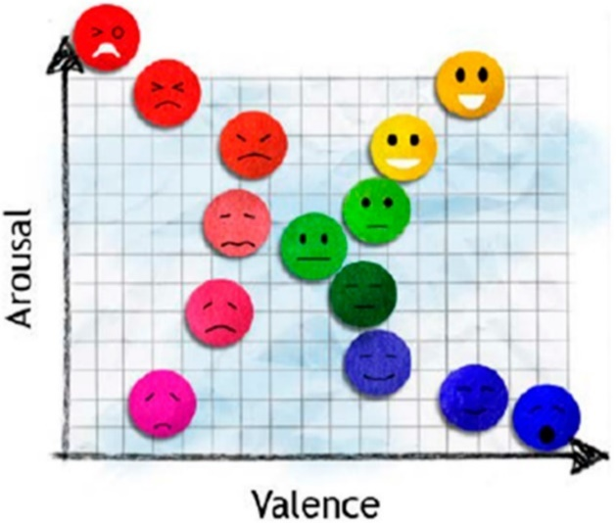

Emotional stimuli - IAPS (International Affective Picture System), GAPED (Geneva Affective Picture Database)

Every picture has valence and arousal rating from the scale 1 to 9. 하지만 IAPS는 low valence와 low arousal picture가 부족해 GAPED도 사용

GAPED – 730 picture database, four classical music pieces from auditory emotional research

3.4. Feasibility

Single-channel in-ear EEG evaluation.

Feasibility evaluation Emotion classification experiment using secondary data from the Dataset for Emotion classification using Physiological and Audiovisual Signals (DEAP)

32 channel EEG data from 32 subjects, they watched music video clips

The subjects rated the music video clips on valence–arousal scales. The DEAP dataset was hence labelled, and the classification accuracy on the data could be evaluated by the subjects’ rating

Emotion classification에는 T7과 T8 만이 사용됨

SVM 사용, Six statistical parameters by Picard et al. were used for signal feature extraction on a 3 s time-lapsed window

Butterworth filter notch 50Hz noise, filter EEG signals into five frequency bands; delta, theta, alpha, beta, and gamma bands. Ten-folded cross validation was applied to suppress biases.

3.5. Experiment Setup

Subjects’ emotions were stimulated by pictures and sounds

12 male, 1 female average age of 24. In-ear EEG inserted into either the right ear or left ear according to each subject’s preference, whereas earphones were inserted into the other ears.

REF는 in-ear EEG 넣은 귀 바로 아래 뺨

40 trials recorded per subjects

Each picture was displayer for 30s. Not to move during viewing. 15s black screen was displayed after each picture in order to neutralize subjects’ emotions before the next picture was displayed. Black screen에서는 자유롭게 움직여도 됨 After 8 pictures, subjects could have a small break.

After the experiments were finished, the subjects were asked to evaluate their emotional response on each picture for emotion classification. 개인차가 있을 수 있기 때문

Group comparison with t-tests or ANOVA (SPSS 사용)

S4. Results

4.1. MMN Results

Negative peaks between 200-400ms (both T8 and in-ear EEG signals)

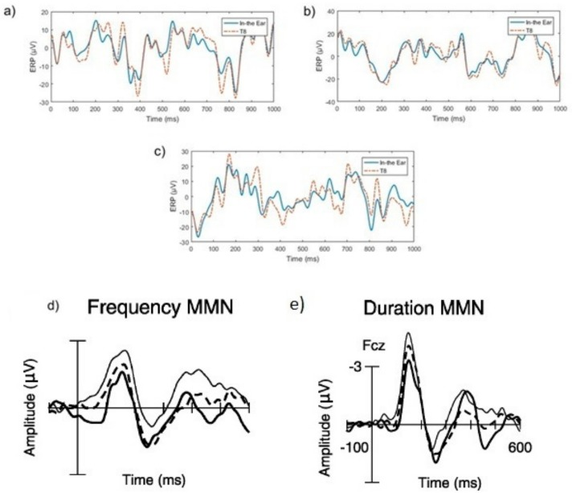

여기서 a,b,c는 각각 frequency mismatch, duration mismatch, ERP response after standard beep

그리고 d,e에서 dotted는 기존의 실험 결과. Thin과 thick는 MMN response

High correlation 0.8530

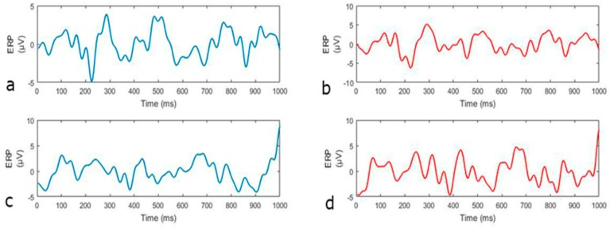

Average frequency mismatch response compared to the standard tone

Blue – In-ear, Red – T8 Up-mismatch, Down-standard

4.2. DEAP Data Analysis

T7&T8 signals from DEAP dataset를 이용해 SVM한 경우

32 subjects x 40 trials. Ten-folded cross-validation 36 training set 4 test set. Ten different sets were trained and tested for each subject.

Valence classification 69.85%, 78.7% arousal classification. Overall accuracy for classifying four emotions 58.12%

T7 or T8 channel을 이용한 경우

T7 Valence 71.30%, Arousal 76.67% Four emotions 57.56%

T8 Valence 70.93%, Arousal 77.20% Four emotions 57.34%

t- test 결과 no significantly difference

->Multichannel classification model과 T7, T8 single channel의 정확도 큰 차이 없기에 single channel로써 사용 가능

4.3. In-ear EEG Emotion Classification

Raw EEG로는 no significant difference between EEG collected from left and right ear

Butterworth 4th order filter

theta (4–8 Hz), alpha (8–12 Hz), beta (12–32 Hz), and gamma (30–48 Hz) 6 statistical parameters signal feature extraction 3s time-lapsed window. 10-fold

SVM classifications와 subjects’ own evaluations를 비교함

73.01% for valence, 75.70% arousal, and 59.23% for all four emotions

In-ear EEG와 T7&T8 signals from the DEAP datasets 비교

Bonferroni test에 따르면, no significant difference

The two-tailed p-values were 0.449 and 0.456, which was over the 0.05

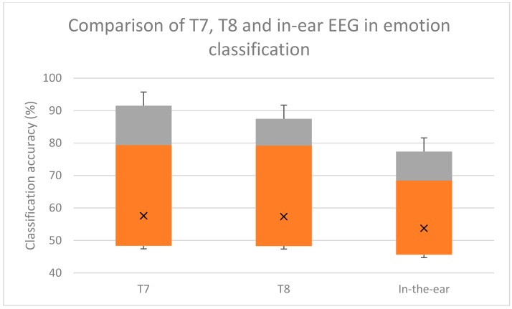 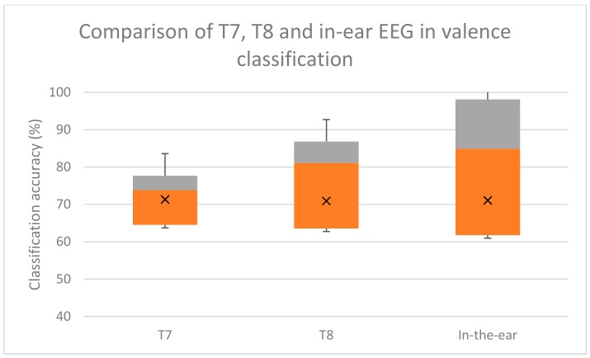 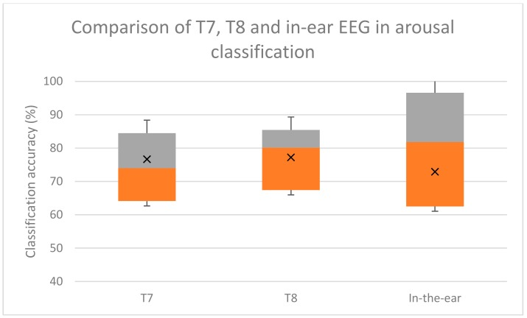

4 emotion In-ear 53.72% T7&T8 58.12%

Valence In-ear 71.07% T7&T8 69.85%

Arousal In-ear 72.89% T7&T8 78.7%

in-ear EEG has potential for emotion classification as T7 and T8 electrodes do

S5. Discussion

MMN results – In-ear EEG signal과 T7&T8 correlation high (둘의 거리 가깝기 때문)

DEAP – T7&T8 single electrode 사용시 valence와 arousal accuracies 70% 넘어 multiple EEG electrodes와 비슷함

In-Ear EEG와 T7&T8 결과 비슷함, 대체 가능

In-ear EEG set up 5분 정도만 소요, 땀에 인한 영향 없어 더운 기후에도 좋음, 착용감 편안함, ear-canal에 딱 맞으면 움직임으로 인한 artifacts 감소

Frontal lobe와 거리가 있어 attention monitoring에는 좋지 않음!

더 많은 채널, 예를 들어 양쪽 귀를 사용하거나 한 device에 여러 개의 electrode를 부착함으로써 정확도를 높일 수 있을 것임

무선 연결로 발전시킬 수도 있지만 integrated circuit design을 ear canal에 맞게 설계해야 하는 어려움이 존재

S6. Conclusion

In-ear EEG device main body – earphone rubber

In-ear EEG electrode – silver-adhesive fabric

Signal 검증 T7&T8의 MMN 비교로 확인 correlation 0.8530

T7&T8의 DEAP emotion classification과 통계적으로 정확도 비슷함

편안함